Passion for Birth Lamaze Childbirth Educator Seminar
April 30 – May 3, 2020 Topsail Beach, NC

Our goal is to “Stomp Out Boring Childbirth Classes”
This seminar is for new or experienced cbes and combines as a beach retreat as it is held in an ocean-front home and has extended afternoon breaks for beach time.

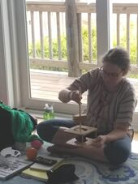

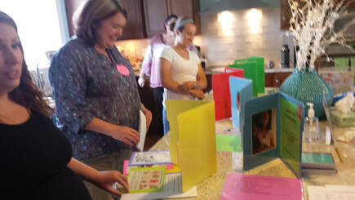
Discover how to use learning stations effectively.
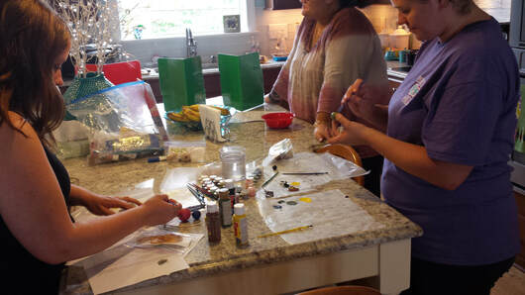
Make fun, interesting visuals to use in class.
Passion for Birth is a Lamaze International accredited program that leads seminars around the world. It is a flexible training program for new and experienced educators.

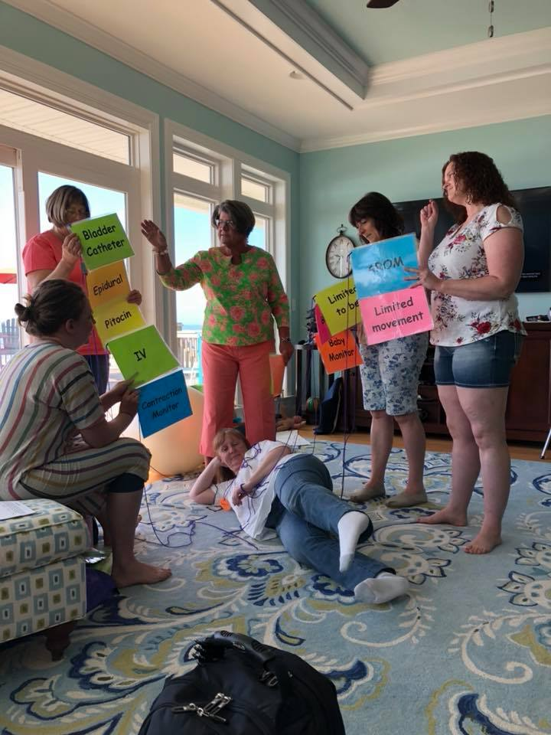
Explore new ways to make your classes fun, interactive, and still evidence based.
For more info: http://www.ncdoula.com/cbe-training.html
Register at passionforbirth.com.

Includes manual of teaching strategies, ceus, seminar, lots of snacks, and 3 meals.

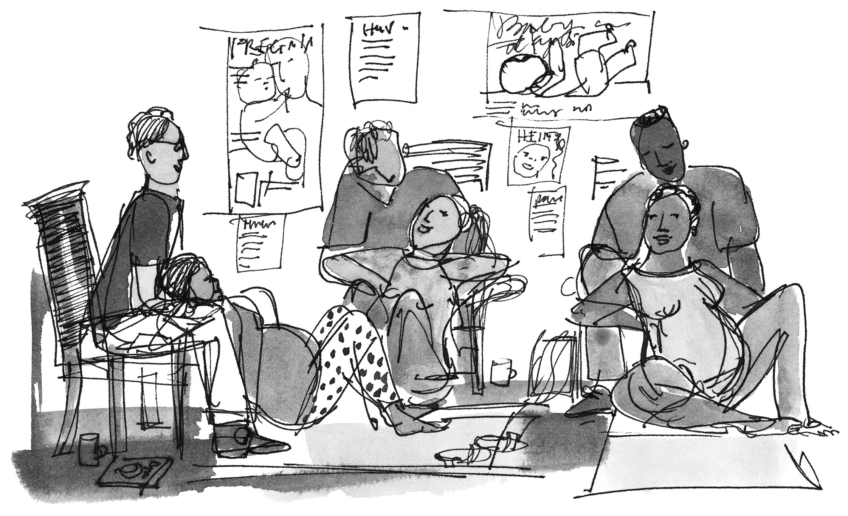
Passion for Birth
Lamaze Childbirth Educator Seminar
April 30 – May 3, 2020

Topsail Beach, NC

Be a dynamic, inspirational, and knowledgeable Childbirth Educator.
Passion for Birth is a Lamaze International accredited program that leads seminars around the world. It is a flexible training program for new and experienced educators.
Passion for Birth’s Mission is to stomp out boring childbirth classes.

To register go to passionforbirth.com. 866-P4BIRTH
Times | Topics
April 30 5-9 PM | Let's Get Started (Pizza dinner)  Ready to Stomp out Boring (and ineffective) CB education  The Lamaze Roadmap – where to go from here
May 1 8 AM – 1 PM | Putting the Pieces Together – What’s in a Lamaze Course? Begin to out line your classes  The Important Mantra: Increase Confidence and Decrease Fear  The Incredible Pregnant Body  The Great Motivator: PAIN / NO PAIN  Let the Fun Begin: Quick Group Teachbacks
May 1 4-7 PM | Stand By Me: The Importance of Labor Support  3 Rs: Rhythm, Ritual, Relaxation
May 2 8 AM-1 PM | Opening: What Birth Is About  Stop Counting to 10  Tough Stuff: Interventions and the Unexpected and Informed Decisions  Being in Touch: Babies  "A Baby Gotta Eat"  Postpartum: The Reality Sets In
May 2 4-7 PM | The Taters in the Group: Group Dynamics  The $$ Side of Things  Diversity, Culture and more  Being an Advocate
May 3 8 AM – 1 PM | Creating Your Course Design  Sharing: Peer Teaching  Closing and Celebrating Our Passion
Plus: 5 hours online education, contact hours.
You will come home with fun visual teaching tools to use in your classes.
We will make them during the seminar.
Lunches and continental breakfasts, nutritious snacks provided.

Ann Tumblin, Program Facilitator Teri Shilling, Program Director
919-306-1957 anntumblin@gmail.com teri@passionforbirth.com

