DONA Birth Doula Workshops (NCdoula.com)
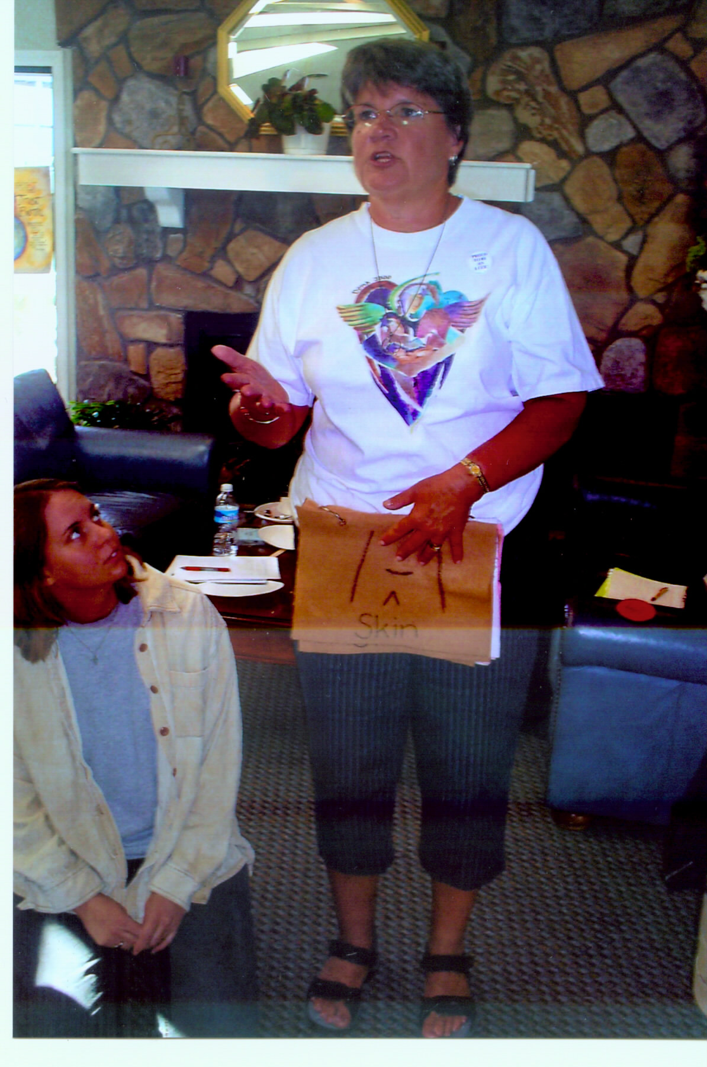

Trainer: Ann Tumblin, LCCE, FACCE, CD(DONA), BDT(DONA) is one of the more
experienced DONA Birth Doula Trainers. She has led over 130 trainings in the past nineteen years. Ann has taught
childbirth classes and provided support for laboring women and their families for over 36 years. In Raleigh she is retired from WakeMed as a perinatal educator and still mentors new doulas there. She has a private doula and doula trainer business.
She is a past DONA treasurer and served on the Certification Committee. She is a faculty member of Lamaze International Passion for Birth Program. She has been a part of faculty at various national conferences including DONA, Lamaze International, MANA, and American College of Nurse-Midwives.
In 2008 she received the Lamaze International Award for her work in Korea, China, and Romania.
She and her husband have two grown sons, two daughters-in-law and five grandchildren.

2018 Workshops in Topsail Beach, NC: These are small workshops to permit individualized attention.

Topsail Beach, NC March 16-17, 2019 Introductory Day March 15, 2019

Workshop Agenda:
Day 1
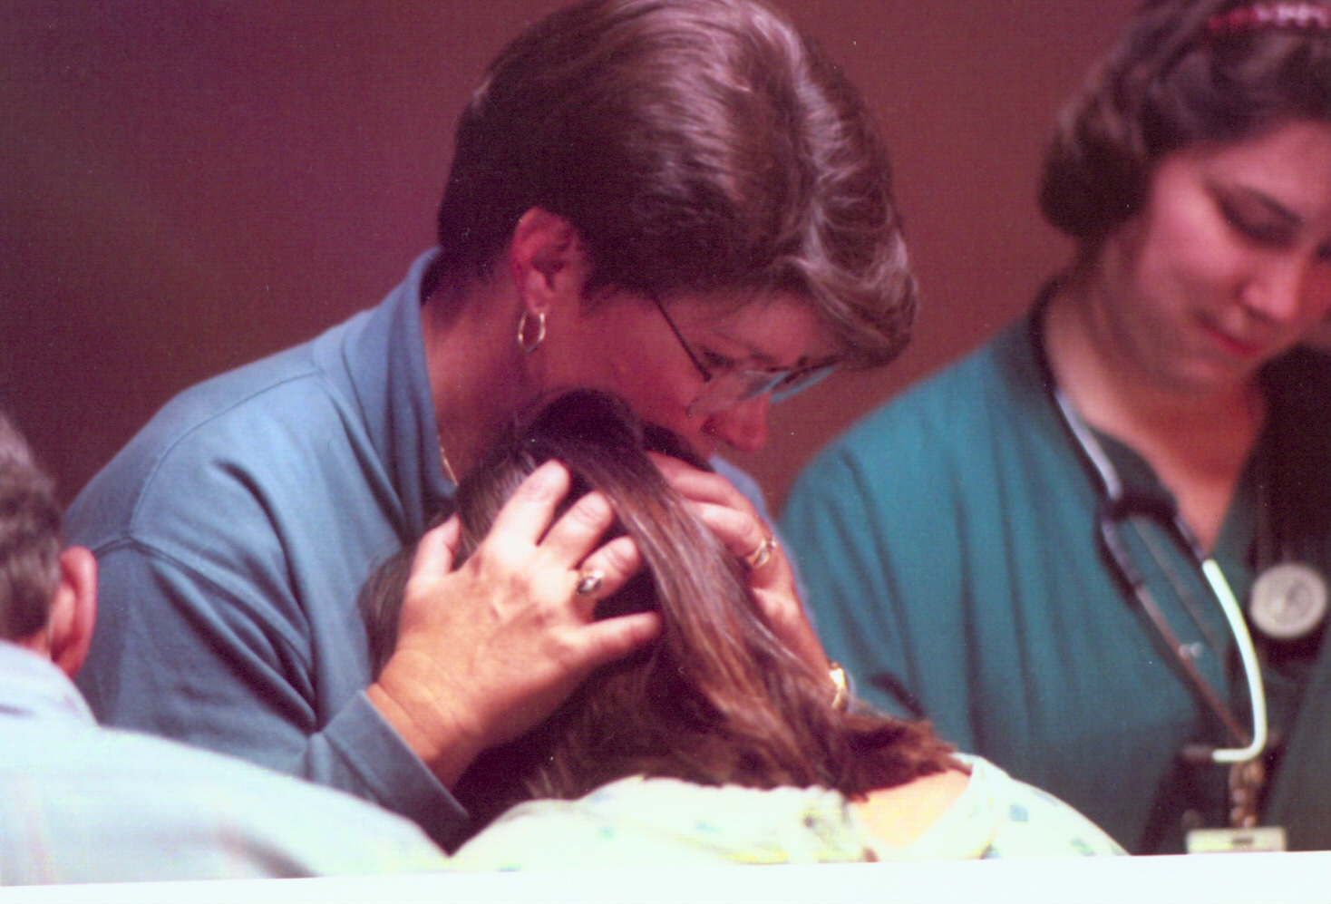
8:30 – 8:45 Registration and Introductions
8:45 – 12:30 Significance of Birth, Prenatal Contact, Birth Plans
12:30 - 1:15 Lunch (provided)
1:15 - 6:00 Professional Role of the Doula (DONA Certification, Business
Support During Stage I & Physical Comfort Measures

Day 2
8:30 – 12:30 Support During Stage II, Medications
12:30 - 1:15 Lunch (provided)
1:00 - 6:00 Challenging Labors, Initial Breastfeeding, Postpartum Contact
Role Play of Labor
6:00 Closing, Evaluations
You must purchase and bring with you to the workshop a copy of the 4th edition of The Birth Partner

Prerequistes:
1. DONA Reading List : You will find complete information about DONA Birth Doula Certification including the reading list here: https://www.dona.org/wp-content/uploads/2016/08/Certification-Overview-Birth-1.pdf
2. This workshop assumes a basic knowledge of pregnancy and childbirth either as a childbirth educator, nurse with labor and delivery experience, or through midwifery. If you do not have this background, you must audit a childbirth class series (not as a pregnant woman) taught by a nationally certified instructor (see DONA.org) before this workshop.
The childbirth education series should consist of no less than 12 hours of class instruction. A letter from the instructor must accompany your application for DONA certification.
*An alternative for observing the childbirth education class is attendance at an Introductory Day taught by a DONA-Approved Doula Trainer. See workshop dates. An Introductory Day is offered the day prior to the workshop. This day is 8:30 - 5:00.
Introductory Day Agenda
8:30 – 9:00 Introductions, Overview, History of Birth
9:00 – 12:00 Normal process of birth, Normalcy of pain in labor and coping strategies
12:00 - 12:45 Lunch (provided)
1:00 – 3:00 Interventions and their effect on labor and birth
3:00 – 5:00 Babies , postpartum, and breastfeeding

For DONA Birth Doula Certification: dona.org

Fees:
Birth Doula Workshop (early) $375.00 (Includes continental breakfast, lunch, snacks, manual and materials)
Introductory Day $95.00 (Includes continental breakfast, lunch, snacks, manual, and materials)
Late workshop registration $400.00 (Includes above items but not Introductory Day)
(Less than one month prior to the workshop)

Make checks payable and send to Ann Tumblin, PO Box 3473, Topsail Beach, NC 28445, OR pay at ncdoula.com

No refunds within one month of the workshop. Refund requests must be made in writing. A 15% service charge is applied.
Registrations can be transferred one time to a future workshop.

Confirmation information and directions will be sent to your email address.

Registration Form: Please complete and send to me via of anntumblin@gmail.com

Registration Form for Birth Doula Workshops

Name ___________________________________________

Address ________________________________________

City, State Zip ___________________________________

Phone ___________________________________________

Email ___________________________________________

Background with birth (optional) ___________________________________________________

_______ I agree to fulfill the required prerequisites for this workshop. (please initial)

_______ I will be attending the March 16-17, 2019 workshop in Topsail Beach, NC

_______ I will be attending the Introductory Day on March, 15, 2019

